Storage Performance Audit – Austin Health

# Overview

TrakCare relies on predictable and optimal storage performance to provide optimal application response times. As part of the performance validation check, InterSystems uses various tools and utilities to measure the throughput and response time of various IO operations.

For system performance a minimum number of disk spindles are required. Using the Performance Report from August 2009 that looked at the existing TrakCare system, the observed peak IOPS was 1200. Allowing for a 5% growth, **1688** IOPS has been assumed for the database disk group.

# Summary

**Storage Array usage:** It is understood there is at least one other application sharing the same storage pool as TrakCare. It is not recommended that any other applications use the same storage pool of disks as the TrakCare environment.

**Database Random Reads:** The read response time of the array is excellent when the databases reside in the SSD storage (< 2.5ms). When the databases reside in the SAS storage the response times fall just outside of the acceptable range (7ms).

**Database Writes:** The write response time of the array is in the acceptable range (averaging < 1ms).

**Journal Sync Response Time:** The journal sync response time of the application servers is very good (< 1ms) and well within the acceptable range.

# Storage Array Details

Storage pool that TrakCare is hosted on contains:

* 5 x SSD Flash drives
* 15 x SAS drives
* 15 x Near Line SAS drives
* LUNS are spread across the RAID groups. So a LUN could be spread across Flash, NL SAS and SAS.
* FAST-CACHE real-time auto-tiering is enabled

Applications using this Storage Array:

* TrakCare T2010
* To be confirmed by AH

**NOTE**: It is not recommended that any other applications use the same storage pool of disks as TrakCare.

SAN cache settings:

* Page Size – 8Kb
* Read Cache – 479Mb on each controller
* Write Cache – 4681Mb on each controller

Server:

* 2x10-core PowerEdge R810 (Intel Xeon E7-4870, 2.4 GHz)
* Server 64GB of physical memory.
* 2x100GB internal SSDs
* Windows 2008 Server Enterprise R2

Caché DB:

* Global buffers = 24000MB and Routine buffers=1024MB

ZREADTEST Database:

* 130GB cache.dat

# Disk Response Times and Throughput

## Database Random Reads

Due to the tiering used in the storage array the disk response times and throughput vary based on where the ZREADTEST database resides.

With the ZREADTEST database not residing in the SSD drive pool the target IOPS of 1688 can be achieved with a response time of 7ms. The target response time for a system with ECP is 4-6ms. Hence this result is out of the acceptable range.

In order to “push” the ZREADTEST database into the SSD drive tier the random read test was initially run a few times using 30 process at 300,000 iterations. This would touch the ZREADTEST database enough times that auto-tiering would push it up into the SSD disk tier.

With the ZREADTEST database residing in the SSD drive pool the storage IO rate is over 2500 physical reads per second with an average response time less than 2.5ms. Hence the target 1688 IOPS can be achieved with 2.3ms response time, which is an excellent result and well below the acceptable range.

As storage array is setup to use the FAST-CACHE auto-tiering it is anticipated the TrakCare databases will typically be located in the SSD drive pool.

## Database Writes

The GMash routine was used over a period of approximately 20mins to produce a large number of database writes into the ZWRITETEST database. During this time the Windows PerfMon utility and Cache´ pButtons utility were used to monitor the performance.

As per the chart below the avg. disk sec/write performance was around the 1 ms region, which is in the acceptable range.

During this time it was also observe via the pButtons data that the Write Daemon was performing between 10,000-20,000 database blocks per seconds

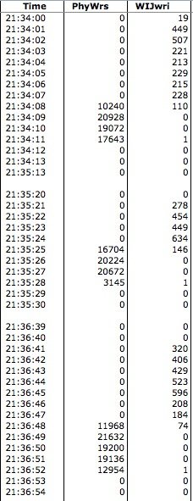

## Journal Sync Response Time

When using TrakCare with application servers and ECP, an internal operation called “Journal Sync” is key to application responsive times of the application servers. To measure the performance of the journal sync an InterSystems tool is used to issue many journal sync requests per second and then measures the response time. The goal for optimal performance is to have 1ms or less on the journal sync operation. The following graph shows that the response times for the journal sync operations are typically well below 1ms. This is very good result and the performance we would expect.

# Conclusion

Based on the results from the random IO and the journal sync generators, the system is optimally sized and appropriately configured to easily handle the predicted TrakCare workload.